**AIM:**

IMPLEMENT CLIENT-SIDE FORM DESIGN AND VALIDATION

To create a client-side form design using HTML5 and validate using JavaScript

**ALGORITHM**:

1. Create an HTML form with fields for Name, Email, Phone, Gender, Country, Service Needed, Needed Within, Upload Project Requirement Specifications, and Message (optional).
2. Add error messages below each field to display validation errors.
3. Write a JavaScript function validateForm() to validate the form fields.
4. In validateForm(), reset any existing error messages using resetErrors().
5. Check if the Name field is empty or contains only whitespace. If so, display an error message.
6. Check if the Email field is a valid email address. If not, display an error message.
7. Check if the Phone field is a valid 10-digit phone number. If not, display an error message. Check if a Gender and Country have been selected. If not, display an error message. If all checks pass, display a success message and submit the form.

**CODE:**

**index.html**

<!DOCTYPE html>

<html lang="en">

  <head>

    <meta charset="UTF-8" />

    <meta name="viewport" content="width=device-width, initial-scale=1.0" />

    <title>My form</title>

    <link rel="stylesheet" href="./style.css" />

  </head>

  <body>

    <div class="container">

      <form id="form" onsubmit="return validateForm()">

        <h1>Contact Me for Projects</h1>

        <fieldset>

          <legend>Personal Details</legend>

          <div class="input-control">

            <label for="name">Name</label>

            <input type="text" name="name" id="name" required />

            <div class="error" id="nameError"></div>

          </div>

          <div class="input-control">

            <label for="email">Email</label>

            <input type="email" name="email" id="email" required />

            <div class="error" id="emailError"></div>

          </div>

          <div class="input-control">

            <label for="phone">Phone </label>

            <input type="tel" name="phone" id="phone" pattern="[0-9]{10}" required />

            <div class="error" id="phoneError"></div>

          </div>

          <div class="gender">

            <label for="gender">Gender</label>

            <input type="radio" name="gender"  value="male" required id="male"/>Male

            <input type="radio" name="gender" value="female" id="female" required/>Female

            <div class="error" id="genderError"></div>

          </div>

          <div class="country">

            <label for="country">Country</label>

            <select name="country" id="country" required>

              <option value="">Select Country</option>

              <option value="India">India</option>

              <option value="USA">USA</option>

              <option value="China">China</option>

              <option value="Australia">Australia</option>

              <option value="Canada">Canada</option>

              <option value="UK">UK</option>

            </select>

            <div class="error" id="countryError"></div>

          </div>

        </fieldset>

        <fieldset>

          <legend>Service Details</legend>

          <div class="service">

            <label for="Service">Service Needed <br /></label>

            <input type="checkbox"  name="service[]" value="web design" id="web"/>Website Development<br />

            <input type="checkbox"  name="service[]"  value="app design" id="app"/>Mobile Application Development <br />

            <input type="checkbox"  name="service[]" value="brand design" id="brand" />Brand Designing <br />

            <input type="checkbox"  name="custom service"  id="custom_service"  placeholder="Custom Service" />Others<br />

          </div>

          <label for="date-of-complete">Needed within</label>

          <input type="date" name="date" id="date-of-complete" /> <br />

          <label for="file-select"

            >Upload Project Requirement Specifications</label

          >

          <input type="file" name="file" id="file-select" />

        </fieldset>

        <div class="msg">

          <label for="msg-area">Message (optional)</label>

          <textarea name="msg" id="msg-area" cols="30" rows="10"></textarea>

        </div>

        <button type="submit">Submit</button>

        <button type="reset">Reset</button>

      </form>

    </div>

    <script>

      function validateForm() {

        resetErrors();

        var nameInput = document.getElementById("name");

        if (!nameInput.value.trim()) {

          showError("nameError", "Name is required.");

          return false;

        }

        var emailInput = document.getElementById("email");

        if (!validateEmail(emailInput.value)) {

          showError("emailError", "Please enter a valid email address.");

          return false;

        }

        var phoneInput = document.getElementById("phone");

        if (!validatePhone(phoneInput.value)) {

          showError(

            "phoneError",

            "Please enter a valid 10-digit phone number."

          );

          return false;

        }

        var genderInputs = document.getElementsByName("gender");

        var genderChecked = false;

        for (var i = 0; i < genderInputs.length; i++) {

          if (genderInputs[i].checked) {

            genderChecked = true;

            break;

          }

        }

        if (!genderChecked) {

          showError("genderError", "Please select a gender.");

          return false;

        }

        var countryInput = document.getElementById("country");

        if (!countryInput.value) {

          showError("countryError", "Please select a country.");

          return false;

        }

        alert("Form submitted successfully!");

        return true;

      }

      function resetErrors() {

        var errorElements = document.querySelectorAll(".error");

        errorElements.forEach(function (element) {

          element.textContent = "";

        });

      }

      function showError(id, message) {

        var errorElement = document.getElementById(id);

        errorElement.textContent = message;

      }

      function validateEmail(email) {

        var emailRegex = /^[^\s@]+@[^\s@]+\.[^\s@]+$/;

        return emailRegex.test(email);

      }

      function validatePhone(phone) {

        var phoneRegex = /^[0-9]{10}$/;

        return phoneRegex.test(phone);

      }

    </script>

  </body>

</html>

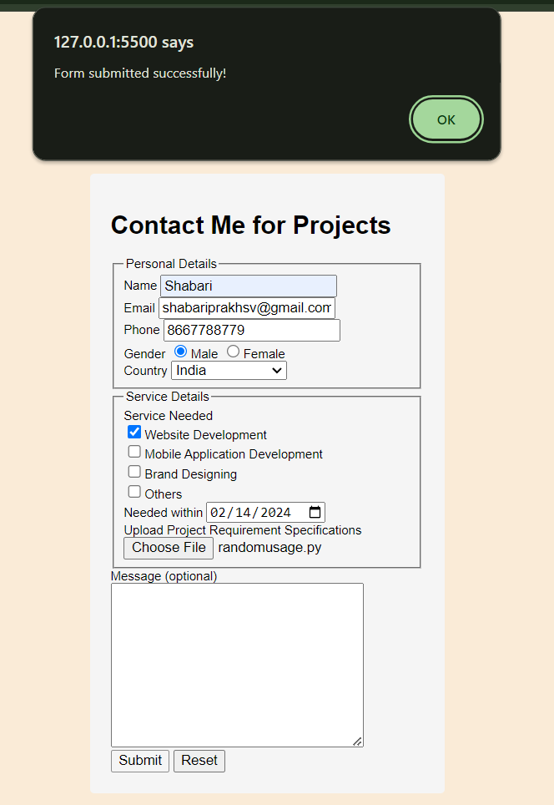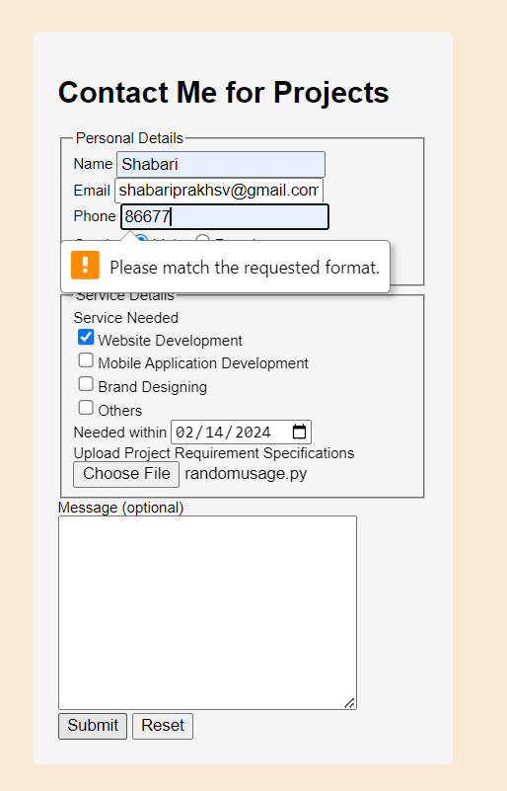**FORM VALIDATION SCREEN SHOT**

**RESULT:** Thus, we have successfully created a client-side form design using HTML5 and validated it using JavaScript